

PIPELINE ROW PATROL INSPECTION REPORT

**GFT  
Encroachment Reports**  
Full System

June 13, 2025

**CONFIDENTIAL DOCUMENTS**

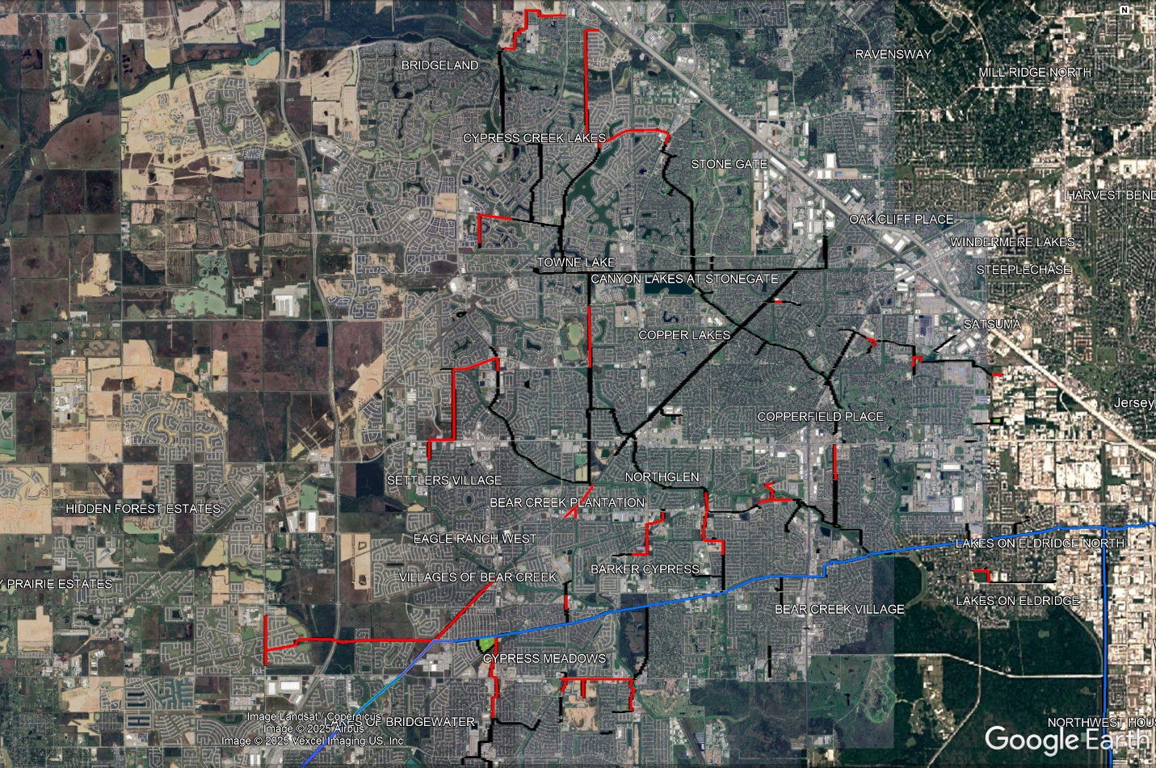

Arch Aerial, LLC

3801 Yale Street

Houston, TX 77018

281.974.5752